[](https://tarrantcounty-tx.aauw.net/)

**For all AAUW Tarrant County Branch Members:**

The information provides an orientation to our organization and communications.   We value our members and hope you find this useful!   (A linked for each item is provided for your convenience.)

**ONLINE RESOURCES**

**[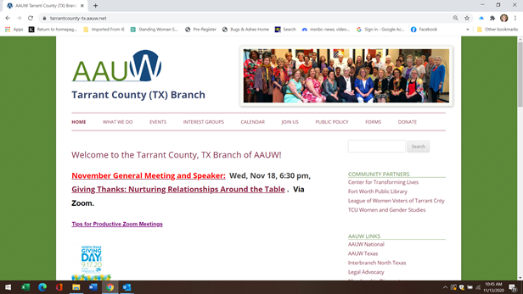](https://tarrantcounty-tx.aauw.net/)**

[**AAUW Tarrant County TX Branch Website**](https://tarrantcounty-tx.aauw.net/)

[**https://tarrantcounty-tx.aauw.net/**](https://tarrantcounty-tx.aauw.net/)

In our website, see the following:

[](https://tarrantcounty-tx.aauw.net/events/)

[**Monthly Program Events**](https://tarrantcounty-tx.aauw.net/events/)

**https://tarrantcounty-tx.aauw.net/events/**

**Who, What, When and Where**

**All events are virtual until further notice.**

**[](https://tarrantcounty-tx.aauw.net/about/interest-groups/)**

[**AAUW TCB Interest Groups**](https://tarrantcounty-tx.aauw.net/about/interest-groups/)

[**https://tarrantcounty-tx.aauw.net/about/interest-groups/**](https://tarrantcounty-tx.aauw.net/about/interest-groups/)

[**Open to all members at all times**](https://tarrantcounty-tx.aauw.net/about/interest-groups/)

**[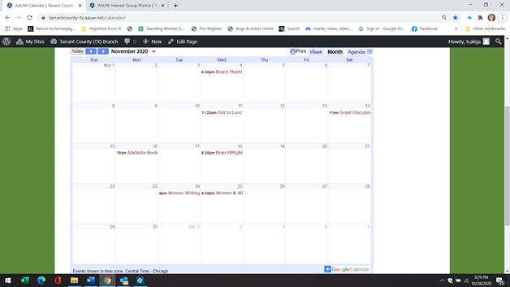](https://tarrantcounty-tx.aauw.net/calendar/)**

[**Branch Calendar**](https://tarrantcounty-tx.aauw.net/calendar/)

[**https://tarrantcounty-tx.aauw.net/calendar/**](https://tarrantcounty-tx.aauw.net/calendar/)

[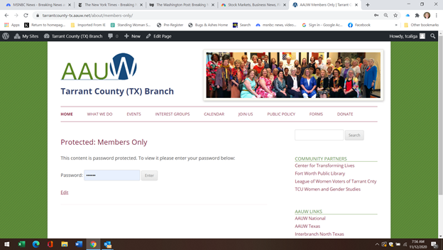](https://tarrantcounty-tx.aauw.net/about/members-only/)

[**Information for Members Only**](https://tarrantcounty-tx.aauw.net/about/members-only/)

[**https://tarrantcounty-tx.aauw.net/about/members-only/**](https://tarrantcounty-tx.aauw.net/about/members-only/)

**(password: Equity)**

Contains Bylaws and Job Descriptions

[**On the Branch Website Also See:**](https://tarrantcounty-tx.aauw.net/)

[Community Service Activities](https://tarrantcounty-tx.aauw.net/local-projects/)

[**https://tarrantcounty-tx.aauw.net/local-projects/**](https://tarrantcounty-tx.aauw.net/local-projects/)

[Public Policy](https://tarrantcounty-tx.aauw.net/public-policy-3/)

[**https://tarrantcounty-tx.aauw.net/public-policy-3/**](https://tarrantcounty-tx.aauw.net/public-policy-3/)

[Photos](https://tarrantcounty-tx.aauw.net/about/facebook-photos/)

<https://tarrantcounty-tx.aauw.net/about/facebook-photos/>

**FACEBOOK**

[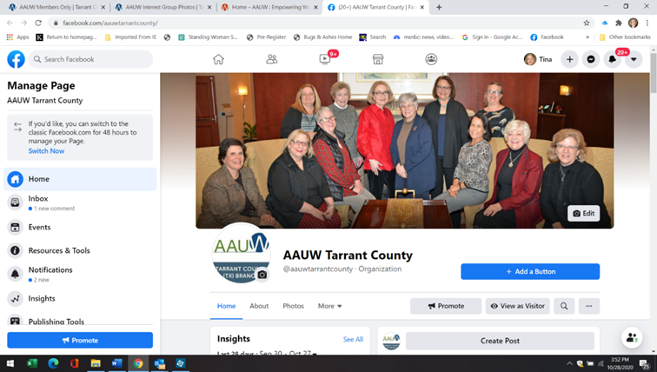](https://www.facebook.com/pages/AAUW-Tarrant-County/176987332491877)

[**AAUW TCB Branch Facebook page**](https://www.facebook.com/pages/AAUW-Tarrant-County/176987332491877)

[**https://www.facebook.com/aauwtarrantcounty/**](https://www.facebook.com/aauwtarrantcounty/)

Past and Future Event Postings

[**AAUW.ORG**](http://www.aauw.org/)

[](http://www.aauw.org/)

[**AAUW National website**](http://www.aauw.org/)

*Learn How to Make a Difference with AAUW*

* [**Explore the Issues**](https://www.aauw.org/issues/)  Sections on Education, Workplace & Economic Equity, and Leadership
* [**Get Empowered**](https://www.aauw.org/get-empowered/)  WorkSmart, Fellowships, and Legal Advocacy
* [**Take Action**](https://www.aauw.org/act/)  Take Action with Two-Minute Activist
* [**Membership Database**](https://ww3.aauw.org/login/?redirect_to=/aauw_redirect/wp_redirect_msd.php)  You can update your Membership Contact Information here. Create a login the first time you enter it.

**Branch Email Communications**

**[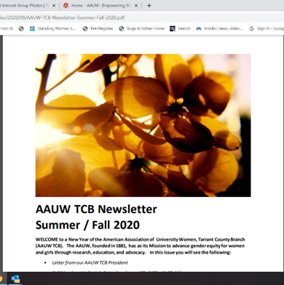](https://tarrantcounty-tx.aauw.net/about/newsletters/)**

**AAUW TCB Newsletter**

Sent quarterly via email

[**Archived on AAUW TCB Website**](https://tarrantcounty-tx.aauw.net/about/newsletters/)

[**https://tarrantcounty-tx.aauw.net/about/newsletters/**](https://tarrantcounty-tx.aauw.net/about/newsletters/)

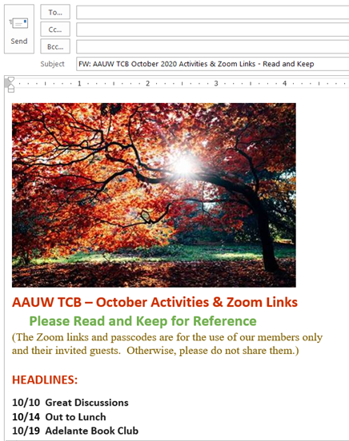

**Monthly Activities Email**

* Emailed to all members at the beginning of the month
* Contains Zoom information for all events and activities

**AAUW TCB PRINTED MEMBER HANDBOOK**

* AAUW

  TARRANT COUNTY BRANCH
  MEMBER HANDBOOK 
  and
  DIRECTORY
  Published and distributed each September
* Contact information for all Current Branch Members
* Branch History, Mission, Strategic Plan and Policy Statement
* Branch and State AAUW Officers
* Community Projects and Fundraising
* Dues Information
* Glossary of AAUW Terms

**AAUW Branch Membership & Dues Information**

* The AAUW **Fiscal Year** is **July 1 - June 30**.
* We are encouraged to submit the AAUW dues for the next year by June 30.
* The current **Regular Member** dues are $88, for the year **July, 2020 - June, 2021.**

1. $59 goes to National AAUW ($56 is tax deductible)
2. $13 goes to Texas State AAUW (not tax deductible)
3. $16 is kept by our Branch ($16 is tax deductible)

* Our Branch has a **nonprofit 501 (c)(3) status**, and $72 of the $88 is tax deductible.
* See [Membership](https://www.aauw.org/membership/) for other membership options.

We strive to keep you well-informed, so you can make the most of your membership in our AAUW Tarrant County Branch.  To get more involved, please contact the chairs of the activities and/or committees that interest you.

Finally, if you have **any ideas** for projects that would benefit our membership and conform with our mission, please submit them to our President, [Orlew Lauger](mailto:o.lauger@sbcglobal.net?subject=AAUW%20Idea)!

**We are so happy you are a member of our Branch!**