September 21, 2020
She Said: Breaking the Sexual Harassment Story that Helped Ignite a Movement Published 2019, 310 pages
Author: Jodi Kantor and Megan Twohey
Genres: Nonfiction, Biography/Autobiography, Sociology, True Crime
Themes: Feminism/Women’s History

From the Pulitzer Prize-winning reporters who broke the news of Harvey Weinstein's sexual harassment and abuse for the New York Times, Jodi Kantor and Megan Twohey, the thrilling untold story of their investigation and its consequences for the #MeToo movement. Includes the journalistic involvement of the two reporters in the Brett Kavanagh nomination. They provide a picture of the attacks on women who work in journalism and the grit needed to unearth the buried stories of sexual harassment in the entertainment industry, as they piece together and reveal the decades-long trail of cover-ups that led to a major cultural revolution for women in our time. Their measured and impeccable approach to their work gives us much to think about and discuss.

Recommended by Susan Davis. Available in Hardcover $21, Paperback $18, Kindle $13, and Audio $20. FW Library has 15 books, 1 Large Print, 4 eBooks, and 4 eAudiobooks.

October 19, 2020
The Ninth Hour, published 2017, 247 pages
Author: Alice McDermott
Genre: Historical Novel
Themes: Feminism/Women’s History

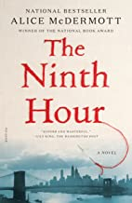
The Ninth Hour, McDermott's eighth novel, is about an order of nursing nuns and the needy families, elderly shut-ins, disabled invalids and strapped widows they care for in a predominantly Irish Catholic neighborhood of Brooklyn.

A young Irish immigrant woman lives with her husband in Brooklyn in the early 1900’s. She is expecting her first child when her husband commits suicide, leaving her without family or any means of caring for herself or her soon to be born child. A nun from the Little Nursing Sisters of the Sick Poor takes her under her wing, and through this Catholic Order, she is provided a job, help with the baby and a social community to belong to. The story follows the growth and development of the mother and child for the next several decades, the choices made by both, and the eventual paths they find themselves on.

Recommended by Cheri Poston. Available in Hardcover $18, Paperback $11, Kindle $10, and Audio $18. FW Library has 8 books, 4 Large Print, 5 on CD, and 1 eBook.

November 16, 2020
Long Bright River, published 2020, 390 pages
Author: Liz Moore
Genre: Suspense Novel
Theme: Opiod Crisis page-turner
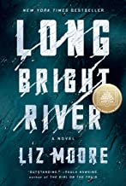
Long Bright River is at once heart-pounding and heart-wrenching: a gripping suspense novel that is also a moving story of sisters, addiction, and the formidable ties that persist between place, family, and fate.

“A thoughtful, powerful novel by a writer who displays enormous compassion for her characters. Long Bright River is an outstanding crime novel… I absolutely loved it." —Paula Hawkins, author of The Girl on the Train

Two sisters travel the same streets, though their lives couldn't be more different. Then one of them goes missing. In a Philadelphia neighborhood rocked by the opioid crisis, two once-inseparable sisters find themselves at odds. One, Kacey, lives on the streets in the vise of addiction. The other, Mickey, walks those same blocks on her police beat. They don't speak anymore, but Mickey never stops worrying about her sibling.

Recommended by Tina Caliga. Available in Hardcover $18, Paperback $18, Kindle $14, Audio $22. FW Library has 8 books, 4 on CD, 3 eBooks and 7 eAudiobooks.

December 21, 2020
Olive, Again, published 2019, 289 pages
Author: Elizabeth Strout
Genre: Novel
Theme: Pleasure reading
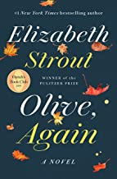
Pulitzer Prize winner Elizabeth Strout continues the life of her beloved Olive Kitteridge, a character who has captured the imaginations of millions.
“Strout managed to make me love this strange woman I’d never met, who I knew nothing about. What a terrific writer she is.”—Zadie Smith, The Guardian
“Just as wonderful as the original . . . Olive, Again poignantly reminds us that empathy, a requirement for love, helps make life ‘not unhappy.’”—NPR

Olive navigating life again! As a sequel to Elizabeth Strout’s Olive Kittredge written 11 years ago, we once again get to step into the shoes of the indomitable Olive as well as observe the goings on in Crosby, Maine. She is getting older and faces new challenges in life. The structure of this book is in 13 short stories, some more and some less involving Olive.

Reading the prequel would enhance the pleasure of Olive Again, but is not absolutely necessary to understand and enjoy this read. There is much to discuss regarding human growth and human interest. It is humorous as well as poignant and many times I did identify with Olive.

Recommended by Eileen Frey. Available in Hardcover $16, Paperback, Kindle $14, and Audio $22. FW Library has 17 books, 7 Large Print, 15 eBooks, 5 books on CD, 8 eAudiobooks and 2 audio media player books.
January 18, 2021
Braiding Sweetgrass: Indigenous Wisdom, Scientific Knowledge, and the Teachings of Plants, published 2013, 390 pages
Author: Robin Wall Kimmerer
Genres: Nonfiction, Memoir
Themes: Nature/Environment, Diverse Cultures

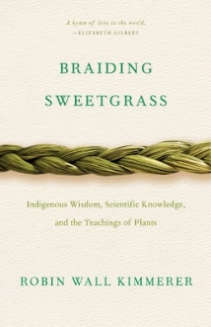
As a botanist, Robin Wall Kimmerer has been trained to ask questions of nature with the tools of science. As a member of the Citizen Potawatomi Nation, she embraces the notion that plants and animals are our oldest teachers. In Braiding Sweetgrass, Kimmerer brings these two lenses of knowledge together to take us on “a journey that is every bit as mythic as it is scientific, as sacred as it is historical, as clever as it is wise” (Elizabeth Gilbert).

Drawing on her life as an indigenous scientist, and as a woman, Kimmerer shows how other living beings―asters and goldenrod, strawberries and squash, salamanders, algae, and sweetgrass―offer us gifts and lessons, even if we've forgotten how to hear their voices. In reflections that range from the creation of Turtle Island to the forces that threaten its flourishing today, she circles toward a central argument: that the awakening of ecological consciousness requires the acknowledgment and celebration of our reciprocal relationship with the rest of the living world. For only when we can hear the languages of other beings will we be capable of understanding the generosity of the earth, and learn to give our own gifts in return. (# 1 Ecology book on Amazon)

Recommended by Joyce Beck and Susan Davis. Available in Hardcover $35, Paperback $14, Kindle $10, and Audio $25. FW Library has 3 books and 2 eAudiobooks.

February 15, 2021
Sing Unburied, Sing, published 2017, 304 pages
Author: Jesmyn Ward
Genre: Novel
Themes: Race and Identity

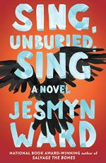
WINNER of the NATIONAL BOOK AWARD and A NEW YORK TIMES TOP 10 BEST BOOK OF THE YEAR

An intimate portrait of a 21st century family, an epic tale of hope and struggle, this book examines the ugly truths at the heart of the American story and the power – and limitations – of family bonds. Jojo is thirteen years old and trying to understand what it means to be a man. His mother, Leonie, is in constant conflict with herself and those around her. She is black and her children’s father is white. Embattled in ways that reflect the brutal reality of her circumstances, she wants to be a better mother, but can’t put her children above her own needs, especially her drug use. ...

Rich with Ward’s distinctive, lyrical language, Sing, Unburied, Sing is a majestic and unforgettable family story and “an odyssey through rural Mississippi’s past and present” (The Philadelphia Inquirer).

Recommended by Randi Thistlethwaite. Available in Hardcover $11, Paperback $8, Kindle $13, and Audio $15. FW Library has 11 books, 7 Large Print, 2 on CD, 4 eAudiobooks, and 1 eBook.

March 15, 2021
Eunice: The Kennedy Who Changed the World, published 2018, 383 pages
Author: Eileen McNamara
Genre: Biography
Themes: Women’s History/Feminism

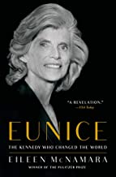
In this “revelation” of a biography (USA TODAY), a Pulitzer Prize–winning journalist examines the life and times of Eunice Kennedy Shriver, arguing she left behind the Kennedy family’s most profound political legacy.
While Joe Kennedy was grooming his sons for the White House and the Senate, his Stanford-educated daughter, Eunice, was hijacking her father’s fortune and her brothers’ political power to engineer one of the great civil rights movements of our time on behalf of millions of children and adults with intellectual disabilities. Her compassion was born of rage: at the medical establishment that had no answers for her sister Rosemary, at her revered but dismissive father, whose vision for his family did not extend beyond his sons, and at a government that failed to deliver on America’s promise of equality.

Recommended by Tina Caliga. Available in Hardcover $8, Paperback $15, Kindle $13, and Audio $16. FW Library has 9 books, 1 eBook, and 1eAudiobook.

April 19, 2021
Poetry Celebration: Bring copies of a poem to share.

May 17, 2021
Circe, published 2018, 391 pages
Author: Madeline Miller
Genre: Fiction
Greek Mythology, strong female protagonist
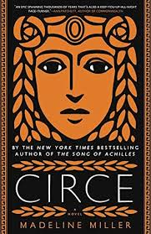
Miller re-imagines the ancient myth of Circe--not powerful like her father, nor viciously alluring like her mother-- who turns to the world of mortals for companionship and who discovers she does have power, the power of witchcraft. Zeus, threatened by Circe's power, banishes her to an island where she improves her skills and crosses paths with many famous mythological characters. Eventually, Circe must decide whether she belongs with the gods she is born from or the mortals she has learned to love.
Recommended by several members; Available in paperback $13. FW Library has 11 books, 1 large print, 3 Audio Media player, 1 EAudio Book.

June 21, 2021
Before We Were Yours, published 2017, 342 pages
Author: Lisa Wingate
Genre: Historical Novel
Theme: Pleasure Reading

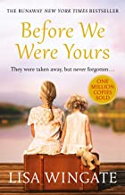
Based on one of America’s most notorious real-life scandals—in which Georgia Tann, director of a Memphis-based adoption organization, kidnapped and sold poor children to wealthy families all over the country—Lisa Wingate’s riveting, wrenching, and ultimately uplifting tale reminds us how, even though the paths we take can lead to many places, the heart never forgets where we belong.

Memphis, 1939. Twelve-year-old Rill Foss and her four younger siblings live a magical life aboard their family’s Mississippi River shantyboat. But when their father must rush their mother to the hospital one stormy night, Rill is left in charge—until strangers arrive in force. Wrenched from all that is familiar and thrown into a Tennessee Children’s Home Society orphanage, the Foss children are assured that they will soon be returned to their parents—but they quickly realize the dark truth.
Publishers Weekly’s #3 Longest-Running Bestseller of 2017 • Winner of the Southern Book Prize

Recommended by Berry Bock. Available in Hardcover $13, Paperback $10, Kindle $13, and Audio $25. FW Library has 18 books, 6 Large Print, and 6 on CD.

July 19, 2021
The Book Woman of Troublesome Creek, published 2019, 308 pages
Author: Kim Michele Richardson
Genre: Historical Novel
Themes: Feminism/Women’s History, Pleasure Reading

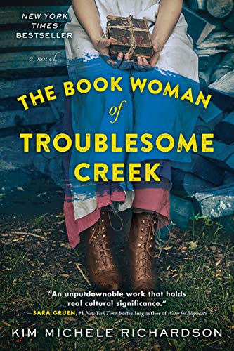
"A unique story about Appalachia and the healing power of the written word."—Kirkus "A timeless and significant tale about poverty, intolerance and how books can bring hope and light to even the darkest pocket of history."—Karen Abbott. "Emotionally resonant and unforgettable, The Book Woman of Troublesome Creek is a lush love letter to the redemptive power of books."—Joshilyn Jackson.

Cussy Mary Carter is a young woman who lives in the Appalachian Mountains of Kentucky during the Depression. She is employed by Kentucky’s Pack Horse Library Project, a program under Roosevelt’s WPA in the 1930’s. As a traveling librarian, she delivers books to the mountain people on horseback along treacherous and dangerous routes. Hoping to bring the joy of books to these hardscrabble Kentuckians, she is met with distrust and prejudice, as she is also one of the last surviving blue-skinned people in the area.
Inspired by the story of the true-blue people of Kentucky and the brave and dedicated Kentucky Pack Horse library service, this is a tale of “raw courage, fierce strength, and one woman’s belief that books can carry us anywhere – even back home.”

Recommended by Cheri Poston. Available in Hardcover $19, Paperback $8, Kindle $8, and Audio $13. FW Library has 8 books, 3 Large Print, and 1 on CD.

August 16, 2021
Cherokee America, published 2019, 399 pages
Author: Margaret Verble
Genre: Historical Fiction
Themes: Diverse Cultures, Post-Civil War Cherokee, Oklahoma Territory, US History
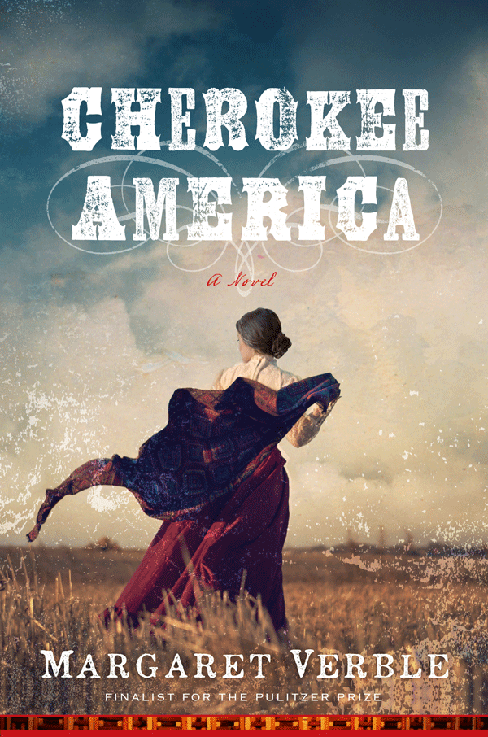
A multilayered, wholly original epic of the American frontier, this novel takes place in post-Civil War Cherokee territory in what is now Oklahoma. Complex alliances and simmering race and culture clashes unite and divide the people living on Cherokee lands. Tensions and violence escalate as the long arm of white law encroaches further into Indian territory. Cherokee America Singer, known as Check, a wealthy farmer, mother of five boys and matriarch of her family, stays determined to survive and thrive on her own terms after decades of betrayal and hardship. Check's family, friends and neighbors must come together to avenge a crime, outwit federal authorities and protect their sovereignty. Based on the author's family history, written with humor and lots of heart, this Western is told from the perspective of a Native American, with a mixed-race woman at its center.

Winner of the Western Writers of America Spur Award (Best Western Traditional Novel)

Recommended by Randi Thistlethwaite. Available in Hardcover $19, Paperback $11, Kindle $3, and Audio $12. FW Library has 3 books.

