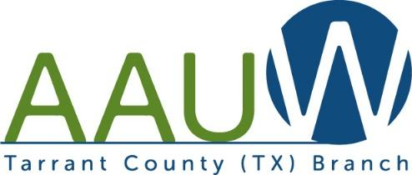

[Addressee Name]
[Address Line 1
[Address Line 2]
[Current date]
AAUW
Tarrant County Branch Board:

President
Orlew Lauger

Program VP
Merrissa Kuylen

Membership VP
Ellen Myers

Funds VP
Cindy Ford

Treasurer
Deborah Roszek

Secretary
Susan Davis

Public Policy
Dawn Ellison

TCC Scholarship
Co-Chairs
Pat Auping
BJ Hoskins

Community Service Chair
Marsha Abeson

North Texas
Giving Day Chair
Barbara Cager

Dear [Addressee],

The American Association of University Women, Tarrant County Branch [type message here] ……

[Addressor]
[Addressor Title]
AAUW Tarrant County Branch is a registered 501(c)(3) non-profit organization and our EIN/federal tax identification number is 75-1510954. As no goods or services will be provided in exchange for your gift, it will be fully tax deductible.

