AAUW Tarrant County Branch STEM Scholarship
Emily Harding

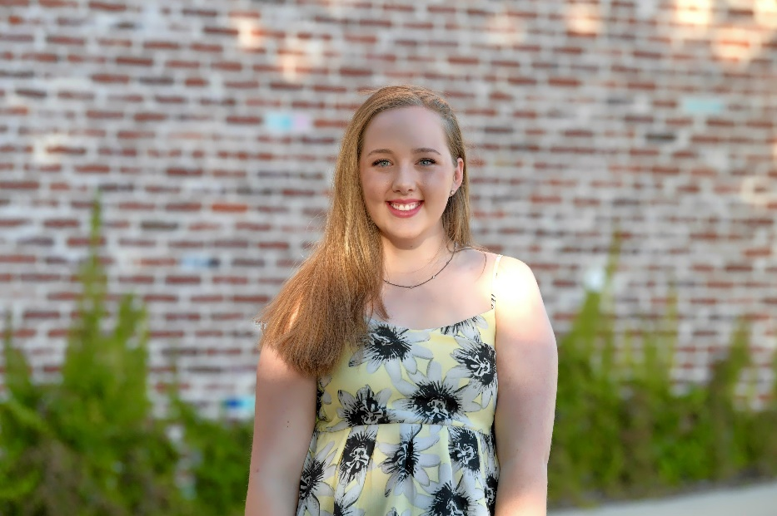
What does receiving this scholarship mean to you? Receiving this scholarship means many things to me. First, it has given me so much more freedom and confidence going into my freshman year of college. It also has such an emotional meaning to me. Receiving this scholarship is a complete honor and I am beyond thankful. Since the scholarship amount will pay for all of my classes at Tarrant County College, I will have a better opportunity to prepare for my transfer to a four-year institution. Lastly, I am proud of myself for qualifying for this scholarship because that means my hard work has paid off.

How did you feel when you heard you were being offered this scholarship? When I heard that I was being offered this scholarship I was dumbfounded. I wasn’t expecting for me to get chosen so I honestly thought it was all a joke, or perhaps I’d been contacted by mistake. Once I realized that it was real, I was ecstatic and relieved.

What are your educational goals and how will this scholarship help you to achieve them? By using the gracious amount of money that this scholarship offers I will have more freedom to continue my schooling up until I earn my masters in psychology. This scholarship has also given me a boost of confidence in myself and my ability to work my way though college.

What are your career goals and how will receiving this scholarship assist in obtaining these goals? I would like to be a behavioral psychologist in the future and this scholarship definitely helps me have the passion and desire to make that dream come true. Knowing that I will be another strong female working in a science career field means so much to me and to have this STEM scholarship makes it even more special. Now that I will be able to pay for at least the first 3 semesters of my college journey gives me so much more confidence and freedom to continue my schooling so that I help so many people in my career.

Please tell the donor about your hobbies and how you like to spend your "down time". In my so-called down time I enjoy doing many things. The one thing that I love doing when I have some free time on my hands is going on walks with my sister, 3 dogs, and my camera to capture the beauty around me. Sadly, I cannot do that every day due to the extreme heat here in Texas or the long thunderstorms we get. So when bad weather strikes, I love to curl up with a good book, music, or movie.

Dear Donor,
I would like to sincerely thank you for the honor of receiving this scholarship. This generous donation not only means so much to me but also it helps out my family in so many ways. Before finding out that I was the recipient of this scholarship I was not looking forward to college due to all of the money it takes. However, now that I know that I will not have to pay for a percentage of my tuition I am more than ready to learn and achieve all of the educational and career goals I have set out for myself. Lastly, I just want to thank you for giving me a chance to prove myself in the science field.
Sincerely,
Emily Harding

