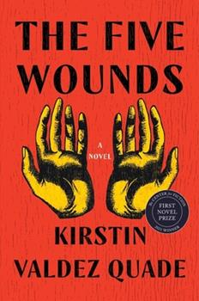
Sept 18, 2023: The Five Wounds by Kirsten Valdez Quade. Discussion Leader: Lorraine Levine. Fiction
It's Holy Week in the small town of Las Penas, New Mexico, and 33-year-old unemployed Amadeo Padilla has been given the part of Jesus in the Good Friday procession. He is preparing feverishly for this role when his 15-year-old daughter, Angel, shows up pregnant on his doorstep and disrupts his plans for personal redemption. With weeks to go until her due date, tough, ebullient Angel has fled her mother's house, setting her life on a startling new path.
Vivid, tender, funny, and beautifully rendered, The Five Wounds spans the baby's first year as five generations of the Padilla family converge: Amadeo's mother, Yolanda, reeling from a recent discovery; Angel's mother, Marissa, whom Angel isn't speaking to; and disapproving Tive, Yolanda's uncle and keeper of the family's history. Each brings expectations that Amadeo doesn't think he can live up to.
The Five Wounds is a miraculous debut novel from a writer whose stories have been hailed as "legitimate masterpieces" (New York Times). Kirstin Valdez Quade conjures characters that will linger long after the book's conclusion, bringing to life their struggles to parent children they may not be equipped to save.

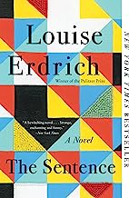
October 16: The Sentence by Louise Erdrich, Fiction.
Discussion Leader: Tina Caliga (Halloween-related, about a haunted bookstore)
Novel asks what we owe to the living, the dead, to the reader and to the book. A wickedly funny ghost story, a tale of passion, of a complex marriage, and of a woman's relentless error. Set in her small indy bookstore, November 2019-20 when the store's most annoying customer. Flora dies on All Soul's Day, but she simply won't leave the store. Tookie, who has landed a job selling books after years of incarceration, must solve the mystery of this haunting while at the same time trying to understand all that occurs in Minneapolis during a year of grief, astonishment, isolation, and furious reckoning.

3 Banned Books: November 13 – Banned Books
Susan Brinkley and Gloria Long suggest this book as a way for TCB to join the fight against banning books in school libraries - and any library. We encourage our members to check out the book - not buy it - to increase circulation. Let the librarians know this is a deliberate choice. We hope to encourage a conversation on the threat these bannings are to our personal liberties.
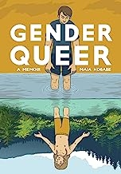
Gender Queer by Maia Kobabe,
Discussion Leaders: Susan Brinkley and Gloria Long
Summary: "In 2014, Maia Kobabe, who uses e/em/eir pronouns, thought that a comic of reading statistics would be the last autobiographical comic e would ever write. At the time, it was the only thing e felt comfortable with strangers knowing about em. Now, Gender Queer is here. Maia's intensely cathartic autobiography charts eir journey of self-identity, which includes the mortification and confusion of adolescent crushes, grappling with how to come out to family and society, bonding with friends over erotic gay fanfiction, and facing the trauma and fundamental violation of pap smears. Started as a way to explain to eir family what it means to be nonbinary and asexual, Gender Queer is more than a personal story: it is a useful and touching guide on gender identity--what it means and how to think about it--for advocates, friends, and humans everywhere."--Amazon.

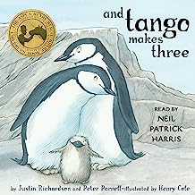
And Tango Makes 3 by Justin Richardson and Peter Parnell.
A true story of 2 male penguins in the New York Zoo that adopt an egg and raise a baby penguin. This sweet story is in the sights of the book- banners! It is a picture book for very young children.

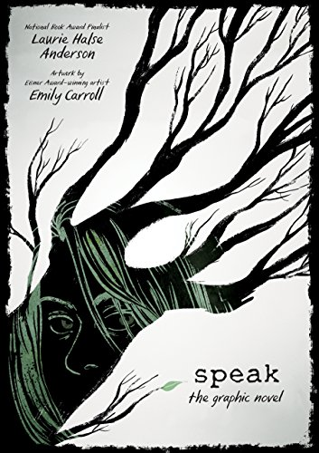
Speak by L. H. Anderson
Summary: "Speak up for yourself--we want to know what you have to say." From the first moment of her freshman year at Merryweather High, Melinda knows this is a big fat lie, part of the nonsense of high school. She is friendless--an outcast--because she busted an end-of-summer party by calling the cops, so now nobody will talk to her, let alone listen to her.

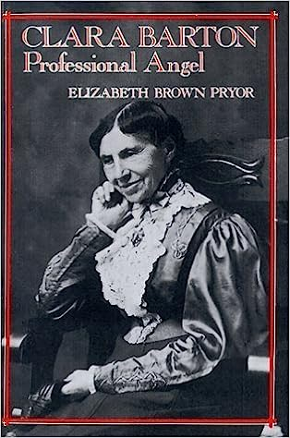
Clara Barton: Professional Angel by Elizabeth Brown Pryor. Biography (not in FW library)
Reviewer: Tina Caliga
Barton established and headed the American Red Cross, was superintendent of a women's reformatory, played a key role in providing medical aid and relief to Civil War battlefronts, and helped establish the New Jersey public school system. Yet her character was far from saintly. Her desire for approval and recognition was boundless, and her overachieving zeal alienated contemporaries. For this outstanding biography, Pryor uses Barton's recently discovered diaries, plus letters and other primary sources, to portray a complex, troubled heroine without delving into historical psychoanalysis. A tribute to a remarkable woman. Highly recommended. ― Library Journal

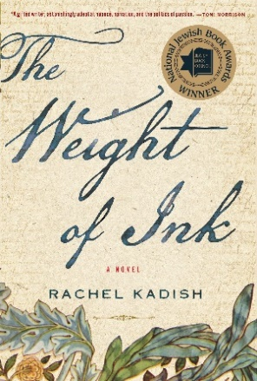
January 15, 2024: The Weight of Ink by Rachel Kadish,
Discussion Leader: Cheryl Poston , Historical Fiction
(longest book, allows 2 months to read)
A story about two women, centuries apart, whose lives revolve around ancient Jewish documents. In 1660's, one is commissioned to act as a secret scribe to a blind rabbi at a time when women are forbidden to do so, and the other is a 21st century, accomplished historian who discovers these documents hidden away in an old house, and attempts to trace their history back to the author of these papers. A story of intelligence, resilience and determination from two women, worlds apart, but both dedicated to the written word.

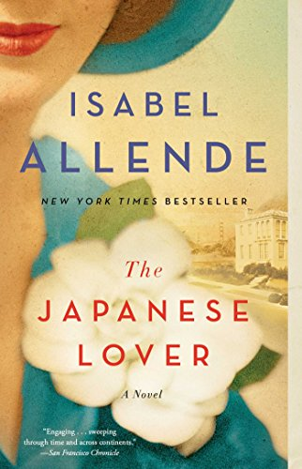
February 19: The Japanese Lover by Isabel Allende, Fiction
Discussion Leader: Joyce Beck
From New York Times bestselling author Isabel Allende, “a magical and sweeping” (Publishers Weekly, starred review) love story and multigenerational epic that stretches from San Francisco in the present-day to Poland and the United States during World War II. It's different and full of surprises, also both enjoyable and challenging. Explores issues of race and identity, abandonment and reconciliation, and centers on two women: elderly, enigmatic Alma and her caretaker, the younger, devoted Irina, who is hiding a dark past.

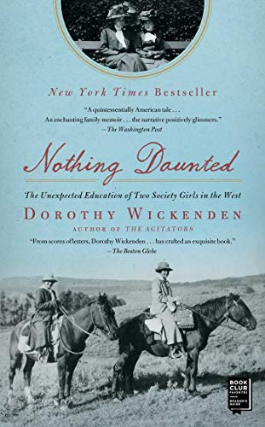
March 18: Nothing Daunted by Dorothy Wickenden, Historical fiction.
Discussion Leader: Eileen Frey
The true story of two restless society girls who left their affluent lives to "rough it" as teachers in the wilds of Colorado in 1916. The author, the granddaughter of one of the teachers, captures their lives and voices through letters written by both of the women to their families and friends.
In the summer of 1916, Dorothy Woodruff and Rosamond Underwood, close friends from childhood and graduates of Smith College, left home in Auburn, New York, for the wilds of northwestern Colorado. Bored by their society luncheons, charity work, and the effete young men who courted them, they learned that two teaching jobs were available in a remote mountaintop schoolhouse and applied—shocking their families and friends. “No young lady in our town,” Dorothy later commented, “had ever been hired by anybody.”
They took the new railroad over the Continental Divide and made their way by spring wagon to the tiny settlement of Elkhead, where they lived with a family of homesteaders. They rode several miles to school each day on horseback, sometimes in blinding blizzards. Their students walked or skied on barrel staves, in tattered clothes and shoes tied together with string. The man who had lured them out west was Ferry Carpenter, a witty, idealistic, and occasionally outrageous young lawyer and cattle rancher. He had promised them the adventure of a lifetime and the most modern schoolhouse in Routt County; he hadn’t let on that the teachers would be considered dazzling prospective brides for the locals.
That year transformed the children, their families…..—Amazon

April 15: Poetry, book not chosen yet.

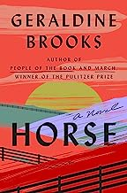
May 20: Horse by Geraldine Brooks, Historical fiction.
Discussion Leader: Randi Thistlethwaite
“Horse isn’t just an animal story—it’s a moving narrative about race and art.”—TIME
“A thrilling story about humanity in all its ugliness and beauty . . . the evocative voices create a story so powerful, reading it feels like watching a neck-and-neck horse race, galloping to its conclusion—you just can’t look away.”—Oprah Daily
"A discarded painting in a junk pile, a skeleton in an attic, and the greatest racehorse in American history: from these strands a Pulitzer Prize winner braids a sweeping story of spirit, obsession and injustice."

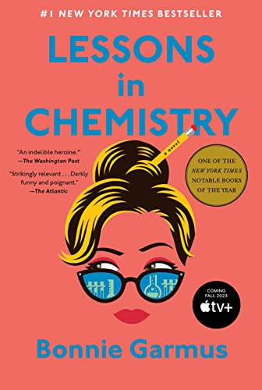
June 17: Lessons in Chemistry by Bonnie Garmus, Fiction
Discussion Leader: Marsha Abeson (very popular, gives time to increase availability at FW Library)
Set in 1960's California, a debut novel. It is a laugh-out-loud funny, thought provoking and uplifting story of a female scientist whose career is constantly derailed by the idea that a women's place is in the home. I recommend it because it is well written and delivers a message, but mainly because it is a delight to read.
Chemist Elizabeth Zott is not your average woman. In fact, Elizabeth Zott would be the first to point out that there is no such thing as an average woman. But it’s the early 1960s and her all-male team at Hastings Research Institute takes a very unscientific view of equality. Except for one: Calvin Evans; the lonely, brilliant, Nobel–prize nominated grudge-holder who falls in love with—of all things—her mind. True chemistry results.
But like science, life is unpredictable. Which is why a few years later Elizabeth Zott finds herself not only a single mother, but the reluctant star of America’s most beloved cooking show Supper at Six. Elizabeth’s unusual approach to cooking (“combine one tablespoon acetic acid with a pinch of sodium chloride”) proves revolutionary. But as her following grows, not everyone is happy. Because as it turns out, Elizabeth Zott isn’t just teaching women to cook. She’s daring them to change the status quo.
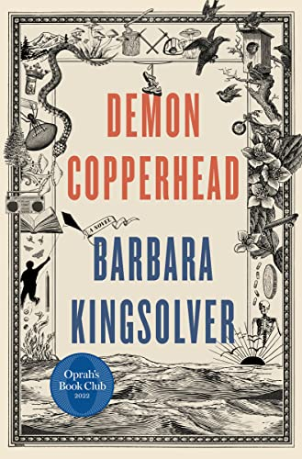
July 15: Demon Copperfield by Barbara Kingsolver, Novel
Won 2023 Pulitzer Prize for Fiction
Discussion Leader: Lorraine Levine
Appalachian version of David Copperfield. Set in the mountains of southern Appalachia, Demon Copperhead is the story of a boy born to a teenaged single mother in a single-wide trailer, with no assets beyond his dead father’s good looks and copper-colored hair, a caustic wit, and a fierce talent for survival. Relayed in his own unsparing voice, Demon braves the modern perils of foster care, child labor, derelict schools, athletic success, addiction, disastrous loves, and crushing losses. Through all of it, he reckons with his own invisibility in a popular culture where even the superheroes have abandoned rural people in favor of cities.
Many generations ago, Charles Dickens wrote David Copperfield from his experience as a survivor of institutional poverty and its damages to children in his society. Those problems have yet to be solved in ours. Dickens is not a prerequisite for listeners of this novel, but he provided its inspiration. In transposing a Victorian epic novel to the contemporary American South, Barbara Kingsolver enlists Dickens’ anger and compassion, and above all, his faith in the transformative powers of a good story. Demon Copperhead speaks for a new generation of lost boys, and all those born into beautiful, cursed places they can’t imagine leaving behind.
-- Amazon
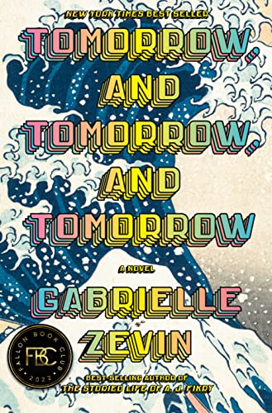
August 19: Tomorrow and Tomorrow and Tomorrow by Gabrielle Zevin, Discussion Leader: Randi Thistlethwaite
"In this exhilarating novel ... two friends--often in love, but never lovers-- come together as creative partners in the world of video game design, where success brings fame, joy, tragedy, duplicity, and ultimately, a kind of immortality." My daughter recommended this and I do too. It delves into a domain many of us know little about and paints a fascinating picture.
Spanning thirty years, from Cambridge, Massachusetts, to Venice Beach, California, and lands in between and far beyond, Gabrielle Zevin’s Tomorrow, and Tomorrow, and Tomorrow is a dazzling and intricately imagined novel that examines the multifarious nature of identity, games as artform, technology and the human experience, disability, failure, the redemptive possibilities in play, and above all, our need to connect: to be loved and to love. Yes, it is a love story, but it is not one you have read before. -- Amazon

